SAMPLE PAPER-2013
CLASS-X
SUBJECT- Mathematics
Time: 3 hours MM :90
GENERAL INSTRUCTIONS
- All questions are compulsory.
- The paper consists of 34 questions divided into four sections A, B, C and D.
- Section A contains 8 MCQs of 1 mark each. Section B contains 6 questions of 2 marks each. Section C contains 10 questions of 3 marks each. Section D contains 10 questions of 4 marks each.
- Question number 1 to 8 in Section A are multiple choice questions where you are required to select any one correct option out of the given four.
- There is no overall choice however internal choices have been provided in 1 question of 3 marks each, 3 questions of 3 marks each and 2 questions of 4 marks each. You have to attempt only one of the alternatives in all such questions
- Use of calculator is not permitted.
SECTION A
- If the sum of the roots of the equation 3x²-(3k -2)x -(k -6) = 0 is equal to the product of its roots, then k =?
  - 1
  - -1
  - 0
  - - 2
- The number of all 2-digit numbers divisible by 6 is
  - 12
  - 15
  - 16
  - 18
- A fair die is thrown once. The probability of getting a composite number is
  - 1/3
  - 1/6
  - 2/3
  - 0
- Which of the following statements is true?
  - The tangents drawn at the end points of a chord of a circle are parallel.
  - From a point P in the exterior of a circle, only two secants can be drawn through P to the circle.
  - From a point P in the plane of a circle, two tangents can be drawn to the circle.
  - The perpendicular at the point of contact to the tangent to a circle passes through the centre of the circle.
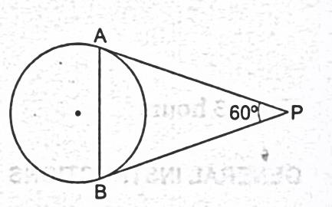
- In the given figure, PA and PB are tangents to a circle such that PA = 8 cm and angle APB = 60°. The lengthof the chord AB is
  - 8 cm
  - 10 cm
  - 12 cm
  - 6cm
- The angle of depression of an object from a 60 m-high tower is 30°. The distance of the object from the tower is
  - 20.√3 m
  - 60.√3 m
  - 40.√3 m
  - 120 m
- In what ratio does the point P(2, -5) divide the line segment joining A(-3, 5) and B(4, -9)?
  - 3:2
  - 2:1
  - 5:2
  - 5:3
- Three solid spheres of radii 6 cm, 8 cm and 10 cm are melted to form a sphere. The radius of the sphere so formed is
  - 24 cm
  - 16 cm
  - 14 cm
  - 12 cm
SECTION B
- For what value of k, given equation has real and equal roots: (k + l) X² - 2(k - l) X + 1 = 0.
Or
Solve for x: 4√3X² + 5X - 2√3 = 0.
- The 8th term of an Arithmetic Progression (AP) is 37 and its 12th term is 57. Find the AP.
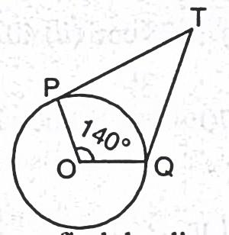
- From a point Q, the length of the tangent to a circle is 24 cm and the distance of Q from the centre is 25 cm., find the radius of the circle.
- In the given figure, if TP and TQ are the two tangents to a circle with centre O so that angle POQ = 140°, find angle PTQ.
- If the perimeter of a semicircular protractor is 36 cm, find the diameter of the protractor. (Take π = 22/7).
- The base radii of two right circular cones of the same height are in the ratio 3 : 5. Find the ratio of their volumes.
SECTION-C
- Solve: a²b²x² - (4b⁴ - 3a⁴)x -12a²b² = 0.
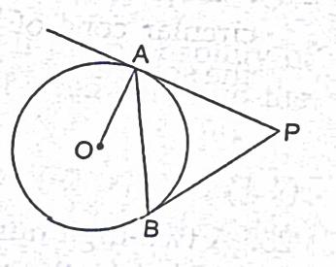
- If the 8th term of an AP is 31 and its 15th term is 16 more than the 11th term, find the AP.
Or,
Find the Sum of all two-digit odd positive numbers.
- In the adjoining figure, PA and PB are tangents drawn from an external point P to a circle with centre O. Prove that angle APB = 2 angle OAB.
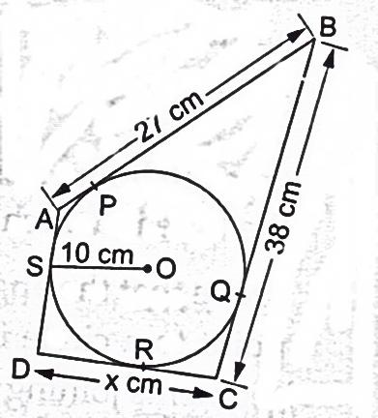
Or,
In the adjoining figure, quadrilateral ABCD is circumscribed. If the radius of the incircle with centre O is 10 cm and AD ┴DC, find the value of x.
- Draw a circle of radius 6 cm. From a point 10 cm away from its centre, construct a pair of tangents to the circle. Measure the length of each of the tangent segments.
- The three vertices of a parallelogram ABCD taken in order are A(1, -2), B(3,6)and C(5,10). Find the coordinates of the fourth vertex D.
- Find the third vertex of a ∆ ABC if two of its vertices are B(-3, 1) and C(0, -2) and its centroid is at the origin.
- Cards marked with all 2-digit numbers are placed in a box and are mixed thoroughly. One card is drawn at random. Find the probability that the number on the card is
  - divisible by 10
  - a perfect square number
  - a prime number less than 25
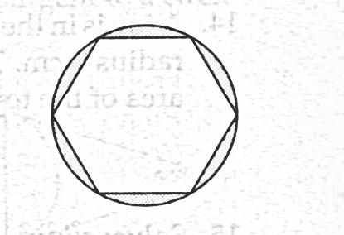
- A road which is 7 m wide surrounds a circular park whose circumference is 352 m. Find the area of the road. [Take π = 22 / 7]
- A round table cover shown in the adjoining figure has six equal designs. If the radius of the cover is 28 cm, find the cost of making the designs at the rate of Rs 0.50 per cm². [Use √3 = 1.73.]
Or,
In an equilateral triangle of side 12 cm, a circle is inscribed touching its sides. Find the area of the portion of the triangle not included in the circle. [Take -√3 = 1.73 and π = 3.14.]
- If a sphere has the same surface area as the total surface area of a circular cone of height 40 cm and radius 30 cm, find the radius of the sphere.
SECTION-D
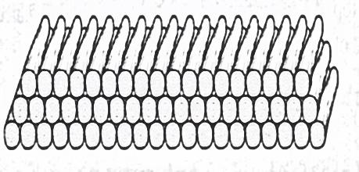
- 200 logs are stacked in the following manner: 20 logs in the bottom row, 19 in the next row, 18 in the row next to it and so on. In how may rows the 200 logs are placed and how many logs are in the top row?
- Find the area of the rhombus whose vertices are (3, 0), (4, + 5), (- 1,4) and (-2, - 1) taken in order
- Four right circular cylindrical vessels each having diameter 21 cm and height 38 cm are full of ice cream. The ice cream is to be filled in cones of height 12 cm and diameter 7 cm having a hemispherical shape on the top. Find the total number of such cones which can be filled with ice cream.
- A box contains 19 balls bearing numbers I, 2, 3, , 19. A ball is drawn at random from the box. What is the probability that the number of the ball is (i) a prime number (ii) divisible by 3 or 5 (iii) neither divisible by 5 nor by 10 (iv) an even number.
- Solve for x: $2\left(\frac{2x+3}{x-3}\right)-25\left(\frac{x-3}{2x+3}\right)=5;given that x≠3, x ≠ \frac{-3}{2}$
Or
If a student had walked 1 km/h faster, he would have taken 15 minutes less to walk 3 km. Find the rate at which he was walking.
- A conical vessel of radius 6 cm and height 8 cm is completely filled with water. A sphere is lowered into the water and its size is such that when it touches the sides it is just immersed. What fraction of water overflows?
- The diameter of a copper sphere is 6 cm. The sphere is melted and is drawn into a long wire of uniform circular cross section. If the length of the wire is 36 cm, find its radius.
- In a school, students thought of planting trees in and around the school to reduce air pollution. It was decided that the number of trees, that each section of each class will plant, will be the same as the class, in which they are studying, e.g., a section of class I will plant 1 tree, a section of class II will plant 2 trees and so on till class XII. There are three sections of each class. How many trees will be planted by the students?
- The angle of elevation of the top of a vertical tower PQ from a point X on the ground is 60°. At a point Y, 40 m vertically above X, the angle of elevation of the top is 45°. Calculate the height of the tower.
- Two circles with centres O and O' of radii 3 cm and 4 cm, respectively intersect at two points P and Q such that OP and O’P are tangents to the two circles. Find the length of the common chord PQ.
Or
The tangent at any point of a circle is perpendicular to the radius through point of contact. Prove it. Use the result to solve the following: From a point Q, the length of tangent to a circle is 6cm and the distance of Q from the centre is 7cm. Find the radius of the circle.
************************

